
Division of Pediatric Neurology
Sinai Hospital of Baltimore
Michel Mirowski
Medical Office Building
5051 Greenspring Avenue Suite 202
Baltimore, MD 21209
Tel 410 601 8300 Fax 410.469.5749

HALA MOHAMED MOUSSA, MD
BILAL SITWAT, MD

Pediatric Neurology Associates

Date: ________________________

Dear Parents/ Guardian,

We would like to take a moment to welcome your child as a new patient of Pediatric Neurology at the Herman and Walter Samuelson Children’s Hospital at Sinai. Your child is typically treated by the same physician, who knows the medical history and family background information. This continuity of care contributes to more positive health care outcomes. We value the critical role that parents play in keeping their children healthy. As a key member of our health care team, you have access to all members of your child’s team and participate in making all decisions about your child’s care. Your family will benefit from a very personal approach to care, similar to the experience of visiting a physician in a private practice.

Prior to your child’s visit, please fax or mail medical records including: x-rays, lab tests, growth charts, office notes pertaining to the visit, and documentation of any ED visits or hospitalizations in the past 3 months. Our fax number is 410 469 5749. Please ensure our office receives your child’s medical records at least 48 hours prior to the scheduled appointment. We ask that you arrive thirty minutes prior to or on time for the appointment or the appointment is subject to be rescheduled to complete the registration process. If you are unable to keep your child’s appointment kindly give 24 hours’ notice. We look forward to meeting you and your child.

_______________________________________ has an appointment with _________________________________________

on ____________________________________________ at_________________ at the ________________________ location.

- Sinai Hospital Michel Mirowski Medical Office Building (main office)
5051 Greenspring Avenue, Suite 202 Baltimore, Maryland 21209

What to Bring with You:

The completed registration packet | Referral from your pediatrician (if applicable)
Insurance cards | A list of medications and questions you may have for the physician.
Photo Identification | If your child is old enough, help him or her to add to the list too
Co-Payment | Books, games, snacks, formula, diapers, change of baby clothes or other necessities.

Division of Pediatric Neurology
Sinai Hospital of Baltimore
Michel Mirowski
Medical Office Building
5051 Greenspring Avenue Suite 202
Baltimore, MD 21209
Tel 410 601 8300 Fax 410.469.5749

HALA MOHAMED MOUSSA, MD
BILAL SITWAT, MD

Directions to Sinai Location

Sinai Pediatric Neurology is now located in the Michel Mirowski Medical Office Building
5051 Greenspring Avenue
Suite 202 Baltimore, MD 21209

From the North
From Pennsylvania and northern Baltimore suburbs, take I-83 South. At junction with I-695 (Baltimore Beltway), enter I-695 heading West (Pikesville direction). Re-enter I-83 South at Exit 23. Proceed for approximately 3 miles and take Exit 10B, Northern Parkway.

From the West
From Howard County and points west, head east on I-70 or on I-795 to I-695 East (Baltimore Beltway, Towson direction). Take Exit 23 onto I-83 South (Jones Falls Expressway). Proceed for approximately 3 miles and take Exit 10B, Northern Parkway.

From the East and Northeast
From Towson, Harford County, and points farther north, take I-95 South to Exit 64, I-695
West (Baltimore Beltway, Towson direction). Take Exit 23 onto I-83 South (Jones Falls Expressway). Proceed for approximately 3 miles and take Exit 10B, Northern Parkway. Head west on Northern Parkway.

From the South
From the DC, MD, VA area, take I-95 North into downtown Baltimore via the I-395 Exit. Turn RIGHT at W. Pratt Street. Turn LEFT at S. President Street, which becomes I-83N/Jones Falls Expressway. Take I-83 North approximately 6 miles to Exit 10B, Northern Parkway West.

DIRECTIONS FROM NORTHERN PARKWAY TO MIROWSKI BUILDING
Proceed 0.6 miles up Northern Parkway and turn left at the stoplight onto Greenspring Avenue. Shortly after you pass under a footbridge across Greenspring Avenue, make the very first left into the driveway that leads up the hill to the parking lot. The driveway entrance is directly across from the Emergency Room (ER7) entrance and is marked by a blue sign pointing to the Mirowski Office Building and the Brain & Spine Institute.

DIRECTIONS FROM THE HOFFBERGER BUILDING TO THE MIROWSKI BUILDING
From the Belvedere Garage turn right onto West Belvedere Avenue, turn right onto Northern Parkway.

Please note the office is on the 2nd floor suite 202 of 5051 Greenspring Avenue. Please expect to pay for parking. Parking is located in front of the building.

MAP OF BUILDINGS AT SINAI LOCATION

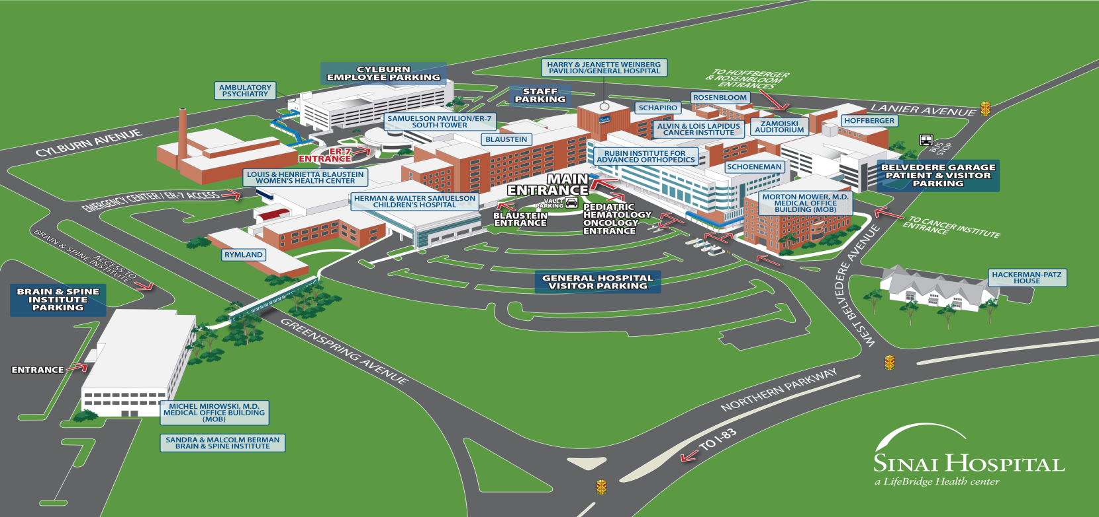
ACROSS FROM SINAI ER SUITE 202
2ND FL

Division of Pediatric Neurology
Sinai Hospital of Baltimore
Michel Mirowski
Medical Office Building
5051 Greenspring Avenue Suite 202
Baltimore, MD 21209
Tel 410 601 8300 Fax 410.469.5749

HALA MOHAMED MOUSSA, MD
BILAL SITWAT, MD
.
IMPORTANT REMINDER CHECKLIST

PLEASE ARRIVE 30 MINUTES PRIOR TO YOUR APPOINTMENT TO COMPLETE THE REGISTRATION PROCESS

Call the PCP’s office to have records sent
(Last office note, growth chart, labs or related test faxed to (410) 469-5749)

Call us 48 hours prior to confirm records were received or at least 24 hours in advance if you need to cancel or reschedule

Bring the COMPLETED New Patient Packet

Bring your state/government issues photo id, patient’s insurance card(s), patient’s referral and/or co-pay, if required by insurance. It is the parents responsibility to obtain a referral to cover the appointment date.
(We accept Master Card, Visa, Discover)

Call us if your phone #, address or insurance changes.

Please expect to pay for parking as there is a fee for parking on the main parking lot as well as in the garage.

**If medical records are not received prior to the appointment, the appointment is subject to being canceled or postponed.**

DIVISION OF PEDIATRIC NEUROLOGY REGISTRATION FORM

Background Information

Welcome to our office. In order to facilitate your child's evaluation, we'd appreciate you providing us with the following information:

Date of appointment: ________________ Provider: Hala Mohamed Moussa, MD Bilal Sitwat, MD

Child's full name: _____________________________________________ Date of Birth: __________________________

Nickname? __________________________________________________ Male : Female:

Name of your child's primary care physician/pediatrician: _______________________________________________________
Physician's Address:________________________________________________________________________________________
Phone # ______________________________________ Fax # ______________________________________________________
Who referred you to our office (if different from physician above)? ________________________________________________
Name and phone number of your preferred pharmacy: __________________________________________________________
Why are you coming to see us today? ________________________________________________________________________

PAIN ? Yes No

Has your child had any medical tests performed due to this condition (X-rays, blood, urine, EEG tests, etc.)? Yes No
If yes, when/where? _______________________________________________________________________________________

Medical History
Medical problems or health concerns:
- _________________________________________________________________________________________________
- _________________________________________________________________________________________________
- _________________________________________________________________________________________________
- _________________________________________________________________________________________________

Prior hospitalizations (Reason/Date/Location):
- __________________________________________________________________________________________________
- __________________________________________________________________________________________________

Prior surgeries or outpatient procedures (Surgery name/Date/Location):
- __________________________________________________________________________________________________
- __________________________________________________________________________________________________
Please list any known medication, food, or other allergies: ___________________________________________________________

DIVISION OF PEDIATRIC NEUROLOGY REGISTRATION FORM cont.

Birth History:
Any problems with pregnancy, labor, or delivery? __________________________________________________________________
Child's birth weight: __________________ Gestational age: ________ weeks
Any medical problems during first month of life?___________________________________________________________________

Social History:
Who lives at home with your child?_____________________________________________________________________________
Any pets at home?__________________________________________________________________________________________
Has your child traveled outside the U.S. in past 6 months?___________________________________________________________
Home drinking water source: __________________________________________________________________________________
Current grade in school: ____________________________
How many school days were missed due to illness in the past year? ____________________________________________________
For what illness(s)? _________________________________________________________________________________________
Any unusual stresses at home or school? _________________________________________________________________________

Has your child been diagnosed with any of the following? Please check all that apply.

Asthma | ADHD/ ADD
Heart Murmur | Anxiety
Anemia | Depression
Diabetes | Other: _____________________________________

Review of Systems:
Please check the box below if your child has experienced any of the following in the past three months:

General | Chills | Fatigue | Irritability | Weight loss or gain | Fever
Skin | Rashes | Jaundice | Other:
Eyes | Vision problems: | Other:
Ear, nose, throat | Hearing loss | Nasal discharge | Strep throat | Mouth sores | Oral thrush
 | Other
Chest | Wheezing | Chest pain | Coughing | Other
Hematology | Bleeding problems | Bruises easily | Other
Genitourinary | Bed wetting | Painful urination | Dark colored urine | Other
Musculoskeletal | Joint pain | Joint stiffness | Joint swelling | Fractures | Other
Neurological | Headache | Loss of consciousness | Seizures | Dizziness | Other

Current age of patient’s: Mother _____ Father _____ Siblings _____ _____ ____ _____ _____ _____

Current Medications:
Medication name | Dose | Frequency (How often it is given)

DIVISION OF PEDIATRIC NEUROLOGY REGISTRATION FORM cont.

Name of MOTHER or female guardian  ______________________________________ | Name of FATHER or male guardian  _____________________________________
Date of Birth: | Date of Birth:
S.S.No.: | S.S.No.:
Home Address: | Home Address:
Home Phone: | Home Phone:
Cell Phone: | Cell Phone:
E-Mail Address: | E-Mail Address:
Employer: | Employer:
Position Held: | Position Held:
Full Time Part-time | Full Time Part-time
Business Phone: | Business Phone:
BEST NUMBER TO CONTACT BEFORE 5:00PM  HOME CELL BUSINESS  BEST NUMBER TO CONTACT AFTER 5:00PM  HOME CELL BUSINESS | BEST NUMBER TO CONTACT BEFORE 5:00PM  HOME CELL BUSINESS  BEST NUMBER TO CONTACT AFTER 5:00PM  HOME CELL BUSINESS

Is your child covered under more than one insurance policy? Yes No

Person responsible for bill Mother Father Guardian/Other (Specify):_________________

Primary insurance co. name: _________________________________Policy No. _________________________

Insurance co. address _________________________________________________________________

Group Name _________________________ Group No. ________________Effective date _________________

Subscriber name ______________________________________ Relationship to patient ____________________

Secondary insurance co. name: ______________________________Policy No. __________________________

Insurance co. address __________________________________________________________________________

Group Name _________________________ Group No. __________________ Effective date ________

Subscriber name ______________________________________ Relationship to patient ____________________

X________________________________ X________________________________
(Patient or Guardian/Date) (Office Official Witness/Date)

Division of Pediatric Neurology
Sinai Hospital of Baltimore
Michel Mirowski
Medical Office Building
5051 Greenspring Avenue Suite 202
Baltimore, MD 21209
Tel 410 601 8300 Fax 410.469.5749

HALA MOHAMED MOUSSA, MD
BILAL SITWAT, MD
.

DIVISION OF PEDIATRIC NEUROLOGY PATIENT AUTHORIZATION FORM

Sinai Hospital of Baltimore Faculty Practice Providers are dedicated to preserving your privacy and personal health information. Our employees are trained in the proper handling of your medical and financial records. We are requesting this Patient Authorization in order to continue to provide the finest medical care possible. Thank you for your assistance.

I authorize ____Sinai Pediatric Neurology ___ to:
(Dept/Division)

- Call my home and/or work to remind me of upcoming appointments; in the event I am not there, leave a message on an answering machine.

- Send reminder notices for upcoming appointments or when it is time to schedule an appointment.

- Call my home or work and leave a message to contact the office. Make and/or receive calls from pharmacies on my behalf, including prescriptions. By FAX.

- Update my personal demographic information either on the phone or in the office at the time of my appointment.

- At my request, I give permission to discuss my personal health with the designated person(s) below:

______________________________ _________________________
Name Relationship

______________________________ _________________________
Name Relationship

______________________________ _________________________
Name Relationship

I have read and agree to the above policies.

____________________________________ __________________________
Patient Name (print) Date

_____________________________________

Signature of Patient/Guardian

