LBHub > Lift Off! Non-Employee Orientation Site

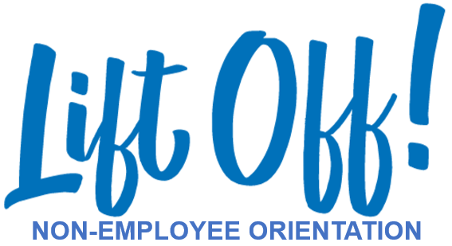

Welcome and thank you for choosing LifeBridge Health.

We appreciate and value your time and contributions. And we hope this orientation will help you to feel welcomed, comfortable, and part of the LifeBridge Health team. If you have any questions or need assistance at any point, please reach out to your coordinator or designated contact.

Thank you.

VOLUNTEERS CLICK HERE
STUDENTS / RESIDENTS CLICK HERE
(COMING SOON)

(PROCEED WITH THE FOLLOWING APPROACH AFTER “Volunteer click”)

START HERE:
LBH Volunteer Orientation Workbook (hyperlink to workbook)
LiftOff! Volunteer Orientation Presentation (hyperlink to presentation)

SELECT YOUR SITE FOR ADDITIONAL INFORMATION:
SINAI
coming soon:
CARROLL
GRACE
LEVINDALE
NORTHWEST

After clicking respective site, should link to page(s) that look something like this:

IMPORTANT INFORMATION FOR REVIEW

(Insert fliers/handouts under Sinai for now)

JOB SPECIFIC INFORMATION FOR REVIEW

(Placeholder for future information.)

CONTACT INFORMATION

(Placeholder for Sinai Volunteer Coordinator name and contact details.)

